Peel the stickers, wash the fruits and vegetables. Serve a healthy bite!

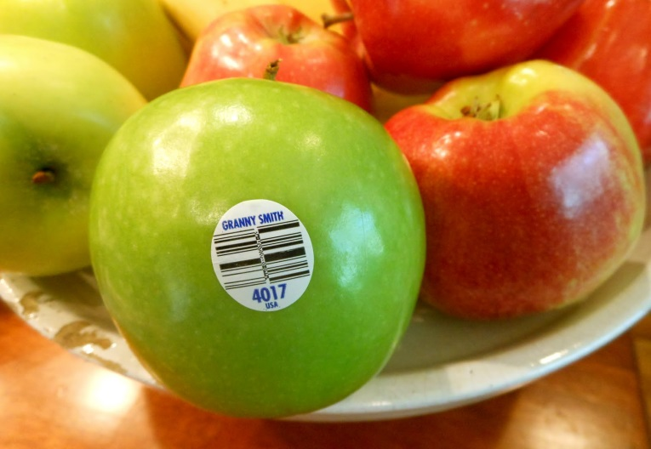
Stickers are small plastic or glued paper information labels, applied to fruits and vegetables in their country of origin, or by supermarkets and food purveyors, which identify the variety, grower, brand name, origin, distributor or bar code.

Although stickers are considered to be non-toxic, the Department considers them to be a “contaminant.” Stickers must be removed before fruits and vegetables are served in a ready-to-eat form.

If the Department observes stickers on fruits or vegetables during an inspection, the fruits or vegetables shall be removed from service, stickers peeled and the items re-washed.

Managers have the option of contacting their purveyor to order produce without stickers.

